**Experiment name:** Constructing a IP Telephony Network.

**Objectives:** To be able to call using VOIP.

**Theory:** IP telephony (Internet Protocol telephony) is a general term for the technologies that use the Internet Protocol's [packet](http://searchnetworking.techtarget.com/definition/packet)-switched connections to exchange voice, fax, and other forms of information that have traditionally been carried over the dedicated circuit-switched connections of the public switched telephone network ([PSTN](http://searchnetworking.techtarget.com/definition/PSTN)). Using the Internet, calls travel as packets of data on shared lines, avoiding the tolls of the PSTN. The challenge in IP telephony is to deliver the voice, fax, or video packets in a dependable flow to the user. Much of IP telephony focuses on that challenge.

We can use Cisco IP telephony solutions to:

* Provide highly secure, reliable, scalable communications that take advantage of your LAN and WAN
* Improve employee agility and productivity through integration with innovative Cisco Unified Communications and third-party applications.

Cisco IP telephony solutions comprise two categories:

* Call processing
* IP phones
  + Wired
  + Wireless
  + Softphones

**Tools:**

1. 7960 IP Phone

2. 2960-24TT Switch

3. 2811 Router

4. Cisko Packet Tracer

**Procedures:**

1. Taking two 7960 IP Phone.

2. Connecting them using 2960-24TT Switch

3. Connect the switch to 2811 router.

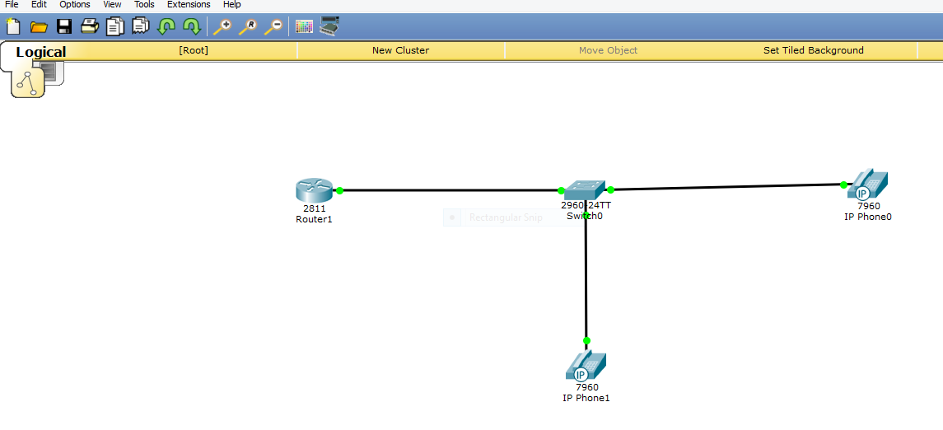

4. Configuring the switch using following command

Switch>en

Switch#conf t

Enter configuration commands, one per line. End with CNTL/Z.

Switch(config)#interface range fa0/1-5

Switch(config-if-range)#switchport mode access

Switch(config-if-range)#switchport voice vlan 1

5. Configuring the router using following command

Router>en

Router#conf t

Enter configuration commands, one per line. End with CNTL/Z.

Router(config)#int fa0/0

Router(config-if)#ip add 192.168.10.1 255.255.255.0

Router(config-if)#no shut

Router(config-if)#exit

Router(config)#ip dhcp pool VOICE

Router(dhcp-config)#network 192.168.10.0 255.255.255.0

Router(dhcp-config)#default-router 192.168.10.1

Router(dhcp-config)#option 150 ip 192.168.10.1

Router(dhcp-config)#exit

Router(config)#telephony-service

Router(config-telephony)#max-dn 5

Router(config-telephony)#max-ephone 5

Router(config-telephony)#ip source-address 192.168.10.1 port 2000

Router(config-telephony)#auto assign 1 to 5

Router(config-telephony)#exit

Router(config)#ephone-dn 1

%LINK-3-UPDOWN: Interface ephone_dsp DN 1.1, changed state to up

Router(config-ephone-dn)#number 54001

Router(config-ephone-dn)#

%IPPHONE-6-REGISTER: ephone-2 IP:192.168.10.2 Socket:2 DeviceType:Phone has registered.

Router(config-ephone-dn)#exit

Router(config)#ephone-dn 2

%LINK-3-UPDOWN: Interface ephone_dsp DN 2.1, changed state to up

Router(config-ephone-dn)#number 54002

Router(config-ephone-dn)#

%IPPHONE-6-REGISTER: ephone-1 IP:192.168.10.3 Socket:2 DeviceType:Phone has registered.

7. Call from phone 54001 to phone 54002

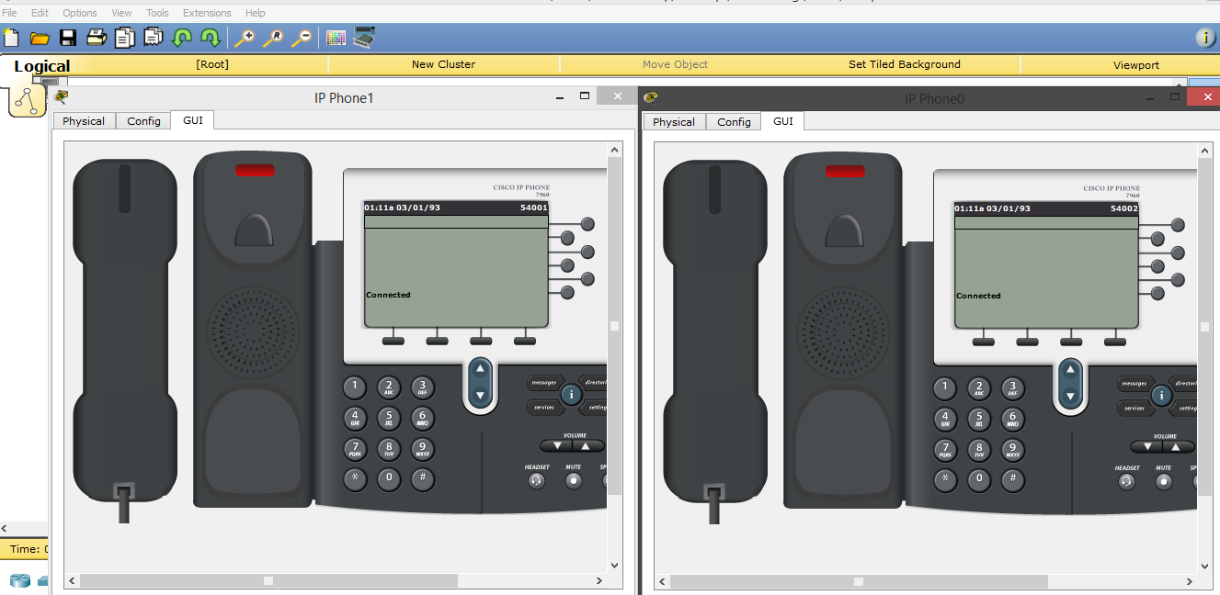

**Conclusion:** By constructing IP telephony network one can call over or using IP.